- INTRODUCTION

  - PROJECT SCOPE
Mobile wireless networks have been used for many mission critical applications, including search and rescue, environment monitoring, disaster relief and military operations. Such mobile networks are typically formed in an ad-hoc manner, with either persistent or intermittent network connectivity. Nodes in such networks are vulnerable to failures due to battery drainage, hardware defects or a harsh environment. Detecting node failures is important for keeping tabs on the network. It is even more important when the mobile devices are carried by humans and are used as the main/only communication mechanism.

1.2 PROJECT PURPOSE
Node failure detection in mobile wireless networks is very challenging because the network topology can be highly dynamic due to node movements. Therefore, techniques that are designed for static networks are not applicable. Secondly, the network may not always be connected. Therefore, approaches that rely on network connectivity have limited applicability. Thirdly, the limited resources (computation, communication and battery life) demand that node failure detection must be performed in a resource conserving manner.

1.3 PROJECT FEATURES
This approach assumes that there always exists a path from a node to the central monitor, and hence is only applicable to networks with persistent connectivity. In addition, since a node can be multiple hops away from the central monitor, this approach can lead to a large amount of network-wide traffic, in conflict with the constrained resources in mobile wireless networks. Another approach is based on localized monitoring, where nodes broadcast heartbeat messages to their one-hop neighbors and nodes in a neighborhood monitor each other through heartbeat messages. Localized monitoring only generates localized traffic and has been used successfully for node failure detection in static networks.

- SYSTEM ANALYSIS

  - PROBLEM DEFINITION
Nodes in such networks are vulnerable to failures due to battery drainage, hardware defects or a harsh environment. Detecting node failures is important for keeping tabs on the network. It is even more important when the mobile devices are carried by humans and are used as the main/only communication mechanism.

  - EXISTING SYSTEM
Mobile wireless networks have been used for many mission critical applications, including search and rescue, environment monitoring, disaster relief, and military operations. Such mobile networks are typically formed in an ad-hoc manner, with either persistent or intermittent network connectivity. Nodes in such networks are vulnerable to failures due to important for keeping tabs on the network. It is even more important when the mobile devices are carried by humans and are used as the main/only communication mechanism.
    - LIMITATIONS OF EXISTING SYSTEM
- Node failure detection in mobile wireless networks is very challenging because the network topology can be highly dynamic due to node movements. Therefore, techniques that are designed for static networks are not applicable.
- The network may not always be connected. Therefore, approaches that rely on network connectivity have limited applicability.
- The limited resources (computation, communication and battery life) demand that node failure detection must be performed in a resource conserving manner.

  - PROPOSED SYSTEM
In this paper, we propose a novel probabilistic approach that judiciously combines localized monitoring, location estimation and node collaboration to detect node failures in mobile wireless networks. Specifically, we propose two schemes. In the first scheme, when a node A cannot hear from a neighboring node B, it uses its own information about B and binary feedback from its neighbors to decide whether B has failed or not. In the second scheme, A gathers information from its neighbors, and uses the information jointly to make the decision.

    - ADVANTAGES OF THE PROPOSED SYSTEM
- Our approach has the advantage that it is applicable to both connected and disconnected networks.
- Our schemes achieve high failure detection rates, low false positive rates, and low communication overhead.

  - FEASIBILITY STUDY
An important outcome of preliminary investigation is the determination that the system request is feasible. This is possible only if it is feasible within limited resource and time. The different feasibilities that have to be analyzed are
- Operational Feasibility
- Economic Feasibility
- Technical Feasibility

2.4.1 Operational Feasibility
Operational Feasibility deals with the study of prospects of the system to be developed. This system operationally eliminates all the tensions of the Admin and helps him in effectively tracking the project progress. This kind of automation will surely reduce the time and energy, which previously consumed in manual work. Based on the study, the system is proved to be operationally feasible.
2.4.2 Economic Feasibility
Economic Feasibility or Cost-benefit is an assessment of the economic justification for a computer based project. As hardware was installed from the beginning & for lots of purposes thus the cost on project of hardware is low. Since the system is a network based, any number of employees connected to the LAN within that organization can use this tool from at anytime. The Virtual Private Network is to be developed using the existing resources of the organization. So the project is economically feasible.

2.4.3 Technical Feasibility
According to Roger S. Pressman, Technical Feasibility is the assessment of the technical resources of the organization. The organization needs IBM compatible machines with a graphical web browser connected to the Internet and Intranet. The system is developed for platform Independent environment. Java Server Pages, JavaScript, HTML, SQL server and WebLogic Server are used to develop the system. The technical feasibility has been carried out. The system is technically feasible for development and can be developed with the existing facility.

  - HARDWARE & SOFTWARE REQUIREMENTS

    - HARDWARE REQUIREMENTS:

Hardware interfaces specifies the logical characteristics of each interface between the software product and the hardware components of the system. The following are some hardware requirements

Processor - i3
- RAM - 8 GB
- Speed - 2.20 GHz
- Hard Disk - 1TB

2.5.2 SOFTWARE REQUIREMENTS:
Software Requirements specifies the logical characteristics of each interface and software components of the system. The following are some software requirements,
- Operating System - Windows 10
- Programming Language - JAVA
- IDE - Eclipse Indigo
- Server - MS Access

- ARCHITECTURE
  - PROJECT ARCITECTURE
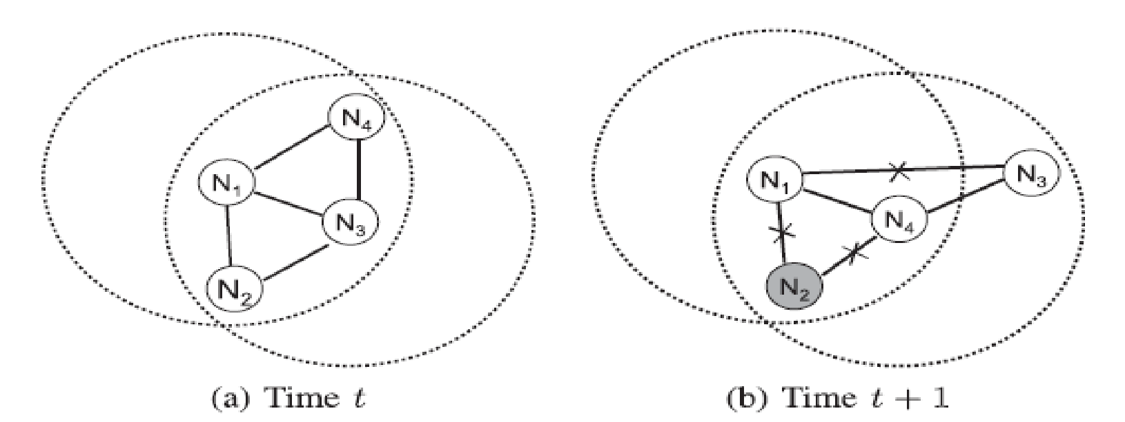
  - MODULES DESCRIPTION
We have 3 main Modules.
- Localized Monitoring Module
- Location Estimation Module
- Node Collaboration Module
3.2.1 Localized monitoring:
Localized monitoring only generates localized traffic and has been used successfully for node failure detection in static networks.
3.2.2 Location Estimation:
By localized monitoring, Node only knows that it can no longer hear from other neighbor nodes, but does not know whether the lack of messages is due to node failure or node moving out of the transmission range. Location estimation is helpful to resolve this ambiguity.
3.2.3 Node Collaboration:
Through this module, we can improve the decisions which are taken during Location estimation module.

  - USE CASE DIAGRAM

Source
Router
Start Nodes

Check Status of all Nodes

Receiving Incoming files
Assign Time

Upload files

Verify Rebroadcasting Time
Upload confirmation

Find Node Failure Details

Find Attackers
Attackers
Destination
Send files
Receive files

Verify files
Store files

  - CLASS DIAGRAM
Members
Methods
Source

Receive (),
Verify_Routing_Time(),
Store (), Accept (), Reject ()

Receiver, fname, Verify_Time, File Content.
Router

Methods
Browse, Send_Files,
File_ Name, Receiver_Name, Router_IP,
Connect (), Receive (), En_route (), Forward (), View_Node_Status, Enter_ Routing_Time,View_Routng _Time,Start_Node, Attack() ,refresh(),Find Attacker,View_Node_Details,Exit().

Files,Receiving_Files,Sending_Files,Time_Delay,Dest_IPAddress,attackers.
Methods

Members

Members

  - SEQUENCE DIAGRAM

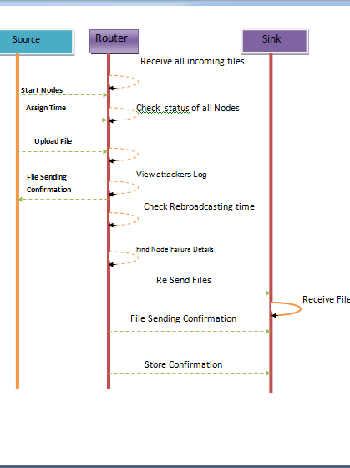

  - ACTIVITY DIAGRAM

Check Node Status
Start Nodes and Assign Routing Time
Source

Router

Upload Files
ON
Forward Files to receiver Node

OFF
Found OFF Nodes

Start From Source with alternative path

Do u want to Rebroadcast ?
NO
Routing of Files Dropped

YES
Start from Source with Default Path

Rebroadcast Time Exceeds Assigned Time ?

YES
Found attacker

No
Receiver

- IMPLEMENTATION
  - SAMPLE CODE
import java.sql.Connection;
import java.sql.DriverManager;

public class DBcon
{
static Connection con;
static Connection getConnection()
{
try
{
Class.forName("sun.jdbc.odbc.JdbcOdbcDriver");
con = DriverManager.getConnection("jdbc:odbc:Driver={Microsoft Access Driver (*.mdb)};Dbq=src\\Rebroadcast.mdb");
}catch(Exception ex)
{
ex.printStackTrace();
}
return con;
}
}

- SCREEN SHOTS
  - ROUTER
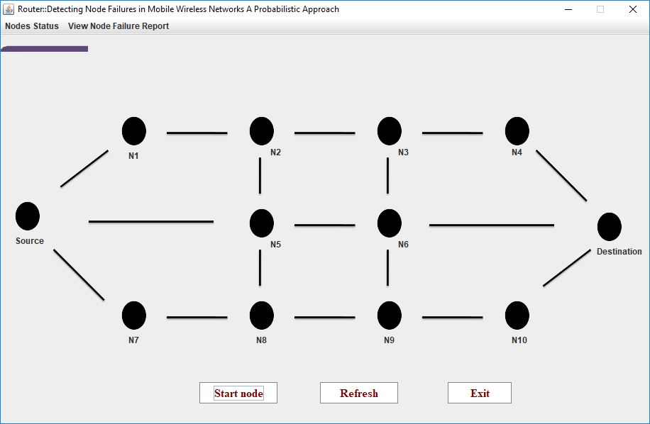
This is the main window where all available nodes are visible.

5.1. Screenshot: Router

  - SOURCE
In this screenshot we can view the source window where user gives text input to be sent to any of the available receivers in the network.

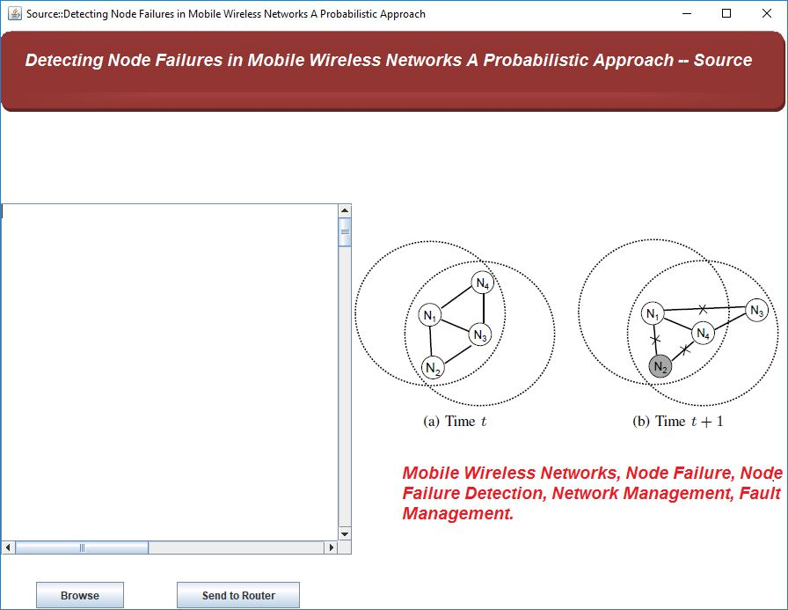
5.2. Screenshot: Source

  - RECEIVER 1
This screenshot shows the receiver window which receives the input from the source.

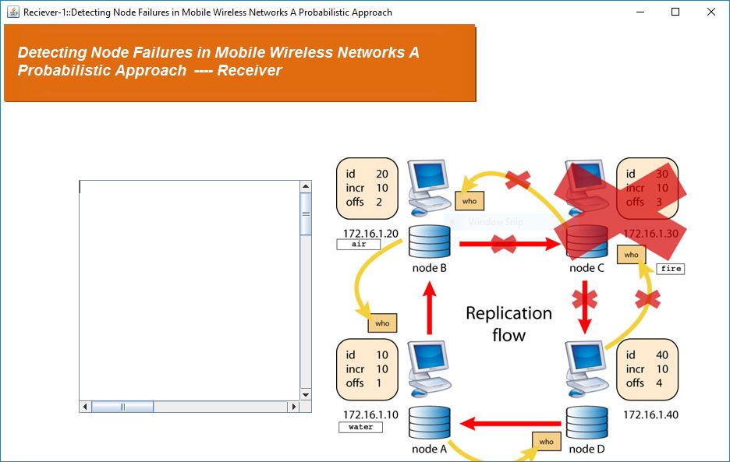

5.3. Screenshot: Receiver 1

  - RECEIVER 2
This screenshot shows the receiver window which receive the input from the source.

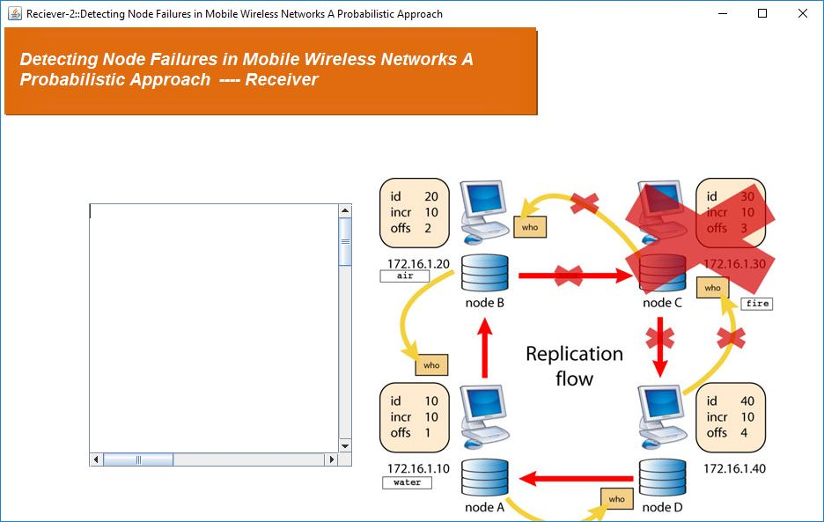

5.4. Screenshot: Receiver 2

  - NODE SELECTION
This window displays the router where the nodes are activated or deactivated in the selected path.

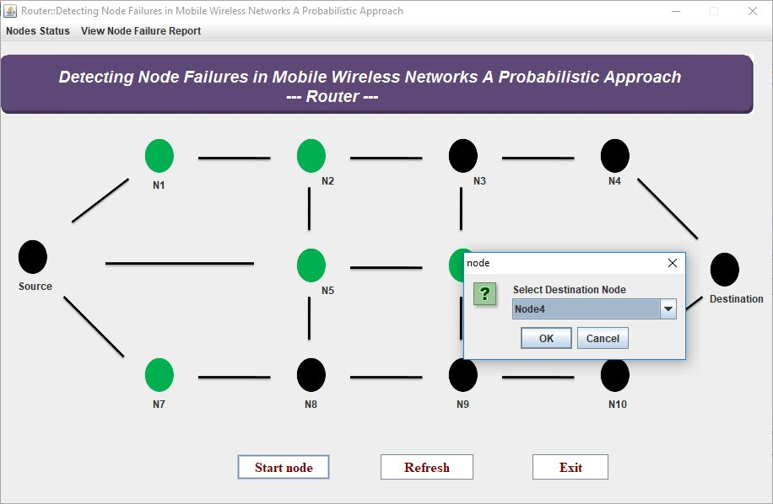

5.5. Screenshot: Node Selection

  - NODE STATUS
In this screenshot the activation status of the nodes in the path is shown.

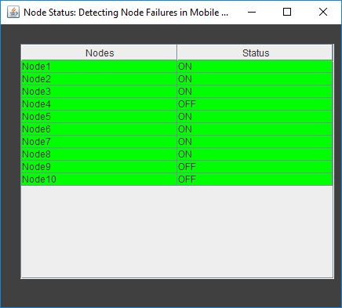

5.6. Screenshot: Node Status

  - CHOOSING RECEIVER
In this screenshot the user selects a receiver from all the available receivers.
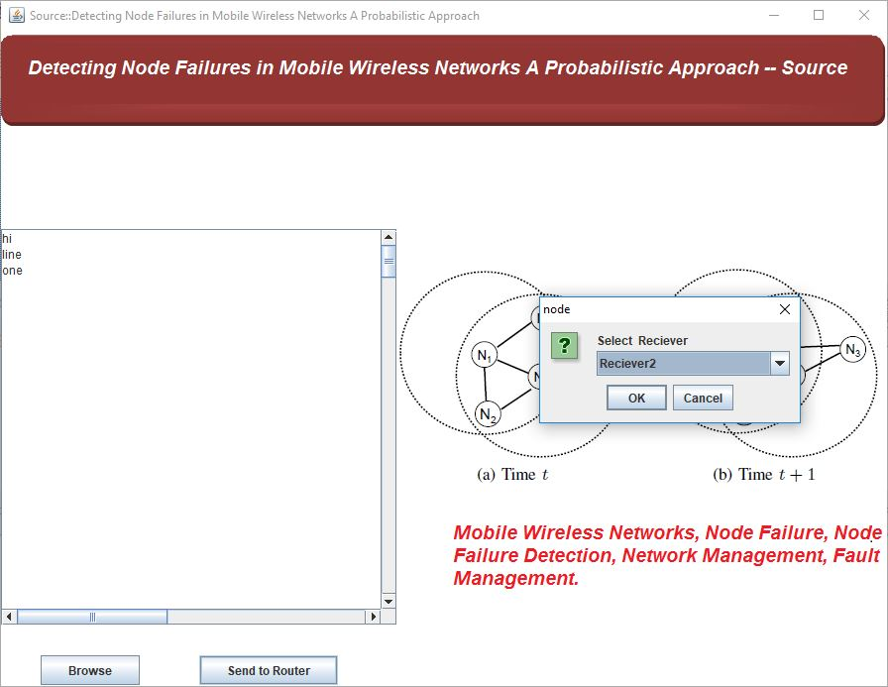

5.7 Screenshot: Selecting a Receiver

  - TIME SELECTION
In this screenshot we can insert time in milliseconds.

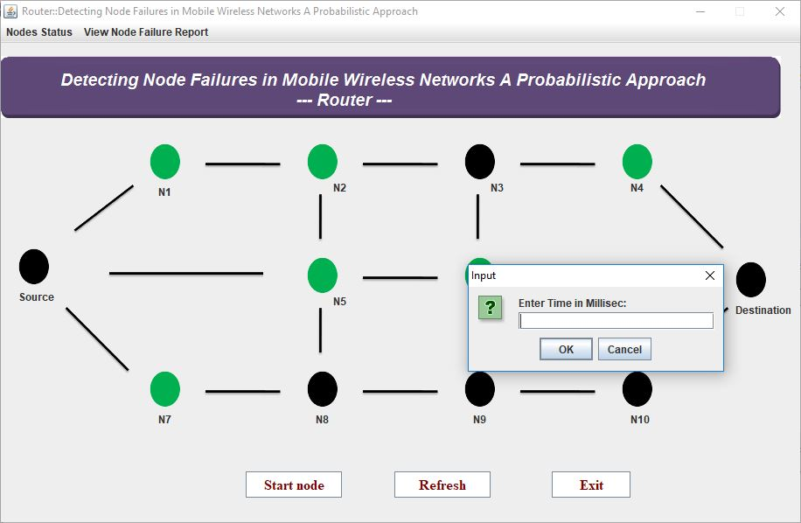

5.8 Screenshot: Time Selection

  - SELECTING IP ADDRESS
An IP Address is given by the user for transmission of data in the network

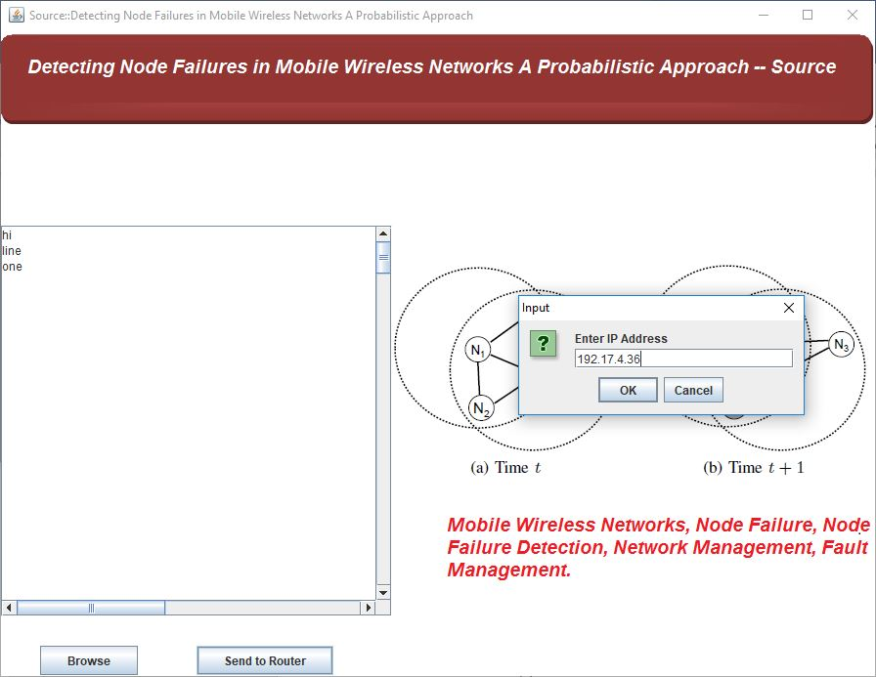

5.9 Screenshot: Inserting an IP Address

  - ROUTING IN NETWORK
The path of transmission of data in the router is seen in this screenshot.

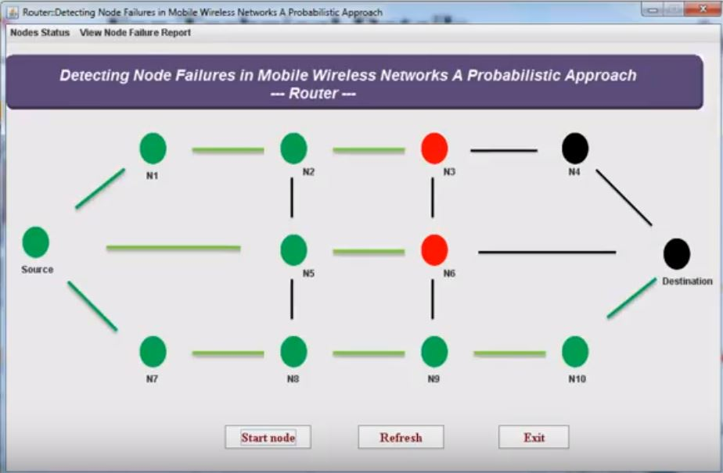

5.10 Screenshot: Data Transmission

  - RECEIVER DATA
After the transmission is completed the data given as input in source is visible in the selected receiver.

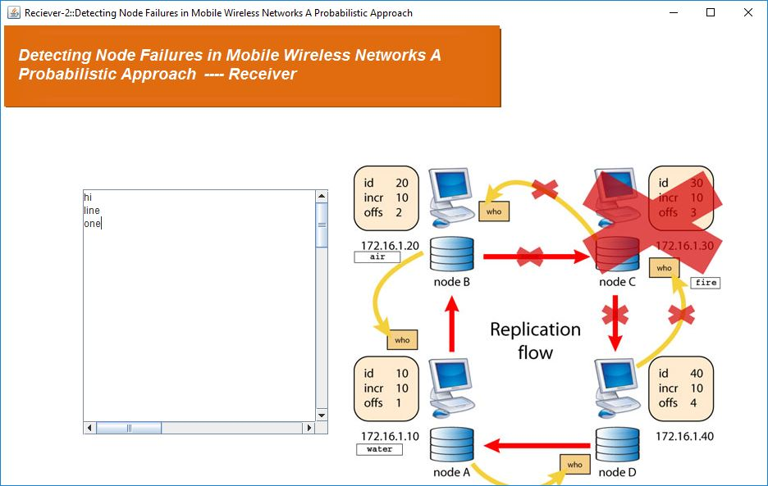

5.11 Screenshot: Data Received

  - REPORT
This screenshot gives the report of the transmission.

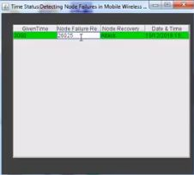

5.12 Screenshot: Report

- TESTING
  - INTRODUCTION TO TESTING
The purpose of testing is to discover errors. Testing is the process of trying to discover every conceivable fault or weakness in a work product. It provides a way to check the functionality of components, subassemblies, assemblies and/or a finished product. It is the process of exercising software with the intent of ensuring that the Software system meets its requirements and user expectations and does not fail in an unacceptable manner. There are various types of test. Each test type addresses a specific testing requirement
6.2 TYPES OF TESTING
6.2.1 UNIT TESTING
Unit testing involves the design of test cases that validate that the internal program logic is functioning properly, and that program inputs produce valid outputs. All decision branches and internal code flow should be validated. It is the testing of individual software units of the application .it is done after the completion of an individual unit before integration. This is a structural testing, that relies on knowledge of its construction and is invasive. Unit tests perform basic tests at component level and test a specific business process, application, and/or system configuration. Unit tests ensure that each unique path of a business process performs accurately to the documented specifications and contains clearly defined inputs and expected results.
- Test objectives
- All field entries must work properly.
- Pages must be activated from the identified link.
- The entry screen, messages and responses must not be delayed.

- Features to be tested
- Verify that the entries are of the correct format
- No duplicate entries should be allowed

6.2.2 INTEGRATION TESTING

Integration tests are designed to test integrated software components to determine if they actually run as one program. Testing is event driven and is more concerned with the basic outcome of screens or fields. Integration tests demonstrate that although the components were individually satisfaction, as shown by successfully unit testing, the combination of components is correct and consistent. Integration testing is specifically aimed at exposing the problems that arise from the combination of components.

Test Results: All the test cases mentioned above passed successfully. No defects encountered.

6.2.3 FUNCTIONAL TESTING

Functional tests provide systematic demonstrations that functions tested are available as specified by the business and technical requirements, system documentation, and user manuals.
Functional testing is centered on the following items:
Valid Input : identified classes of valid input must be accepted.
Invalid Input : identified classes of invalid input must be rejected.
Functions : identified functions must be exercised.
Output : identified classes of application outputs must be exercised.
Systems/Procedures: interfacing systems or procedures must be invoked.
Organization and preparation of functional tests is focused on requirements, key functions, or special test cases. In addition, systematic coverage pertaining to identify Business process flows; data fields, predefined processes.

6.3 SYSTEM TESTING

TESTING METHODOLOGIES
The following are the Testing Methodologies,
- User Acceptance Testing.
- Output Testing.
- Validation Testing.

6.3.1 User Acceptance Testing
User Acceptance of a system is the key factor for the success of any system. The system under consideration is tested for user acceptance by constantly keeping in touch with the prospective system users at the time of developing and making changes wherever required. The system developed provides a friendly user interface that can easily be understood even by a person who is new to the system.
6.3.2 Output Testing
After performing the validation testing, the next step is output testing of the proposed system, since no system could be useful if it does not produce the required output in the specified format. Asking the users about the format required by them tests the outputs generated or displayed by the system under consideration. Hence the output format is considered in 2 ways – one is on screen and another in printed format.

6.3.3 Validation Checking
Validation checks are performed on the following fields.
Text Field:
The text field can contain only the number of characters lesser than or equal to its size. The text fields are alphanumeric in some tables and alphabetic in other tables. Incorrect entry always flashes and error message.

Numeric Field:
The numeric field can contain only numbers from 0 to 9. An entry of any character flashes an error messages. The individual modules are checked for accuracy and what it has to perform. Each module is subjected to test run along with sample data. The individually tested modules are integrated into a single system. Testing involves executing the real data information is used in the program the existence of any program defect is inferred from the output. The testing should be planned so that all the requirements are individually tested.
A successful test is one that gives out the defects for the inappropriate data and produces and output revealing the errors in the system.

6.3.4 Using Live Test Data:
Live test data are those that are actually extracted from organization files. After a system is partially constructed, programmers or analysts often ask users to key in a set of data from their normal activities. Then, the systems person uses this data as a way to partially test the system. In other instances, programmers or analysts extract a set of live data from the files and have them entered themselves
It is difficult to obtain live data in sufficient amounts to conduct extensive testing. And, although it is realistic data that will show how the system will perform for the typical processing requirement, assuming that the live data entered are in fact typical, such data generally will not test all combinations or formats that can enter the system. This bias toward typical values then does not provide a true systems test and in fact ignores the cases most likely to cause system failure.

6.3.5 Using Artificial Test Data:
Artificial test data are created solely for test purposes, since they can be generated to test all combinations of formats and values. In other words, the artificial data, which can quickly be prepared by a data generating utility program in the information systems department, make possible the testing of all login and control paths through the program.
The most effective test programs use artificial test data generated by persons other than those who wrote the programs. Often, an independent team of testers formulates a testing plan, using the systems specifications.
The package “Virtual Private Network” has satisfied all the requirements specified as per software requirement specification and was accepted.

7. CONCLUSION
7.1 PROJECT CONCLUSION
In this paper, we presented a probabilistic approach and designed two node failure detection schemes that combine localized monitoring, location estimation and node collaboration for mobile wireless networks. Extensive simulation results demonstrate that our schemes achieve high failure detection rates, low false positive rates, and low communication overhead. We further demonstrated the tradeoffs of the binary and non-binary feedback schemes. As future work, we plan to evaluate our schemes using real world mobility traces and in scenarios with irregular transmission ranges. Our approach relies on location estimation and the usage of heartbeat messages for nodes to monitor each other. Therefore, it does not work when location information is not available or there are communication blackouts (e.g., due to weather conditions).

7.2 FUTURE ENHANCEMENTS
Developing effective approaches for those scenarios is left as future work.

8. BIBILOGRAPHY
8.1 WEBSITES
- World Wide Web
- www.nsnam.org

8.2 REFERENCES
- R. Badonnel, R. State, and O. Festor. Self-configurable fault monitoring in ad-hoc networks. Ad Hoc Networks, 6(3):458–473, May 2008.
- P. Bahl and V. N. Padmanabhan. RADAR: An in-building RF-based user location and tracking system. In Proc. of IEEE INFOCOM, 2000.
- Y. Bar-Shalom, T. Kirubarajan, and X.-R. Li. Estimation with Applications to Tracking and Navigation. John Wiley & Sons, Inc., 2002.
- D. Ben Khedher, R. Glitho, and R. Dssouli. A Novel Overlay-Based Failure Detection Architecture for MANET Applications. In IEEE International Conference on Networks, pages 130–135, 2007.

